1. create <dependencies > </ dependencies> in pom.xml file

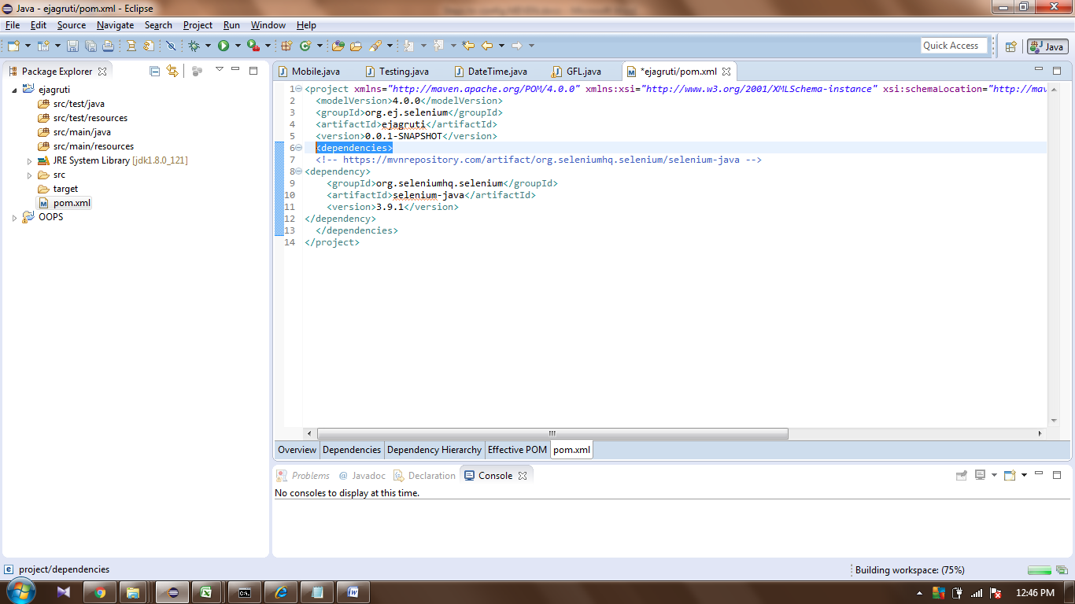

1. Navigate to mvnrepositary.com and copy the dependency data from latest Selenium Java folder

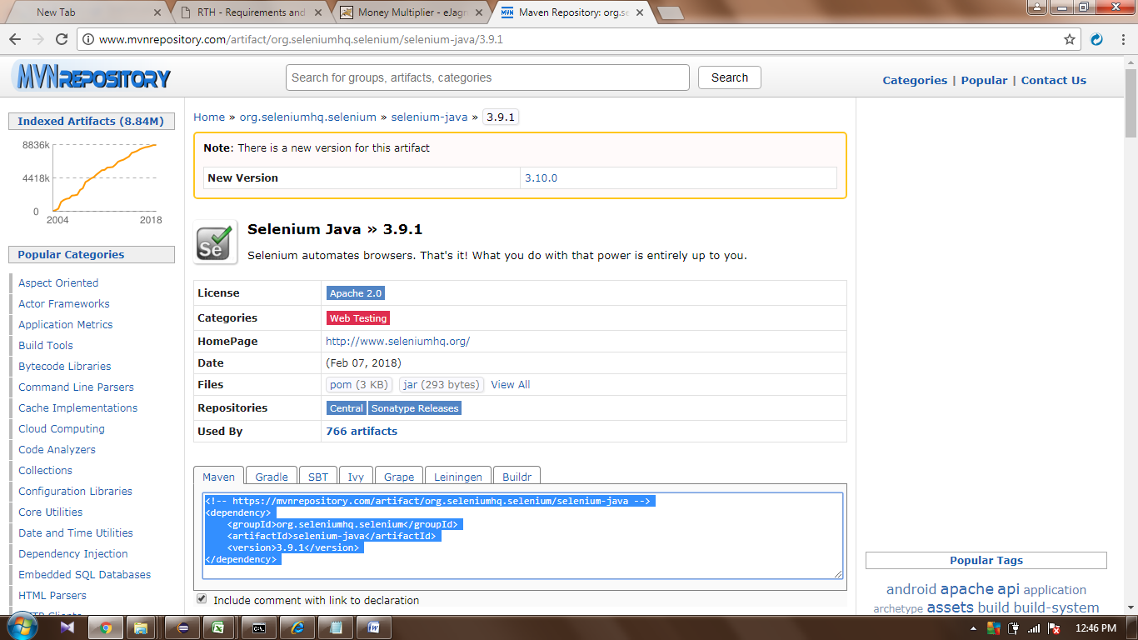

1. Navigate to setting.xml file (Project\maven\config\setting.xml) and copy the path

e.g. = C:\ejagruti-Automation\maven\conf\settings.xml

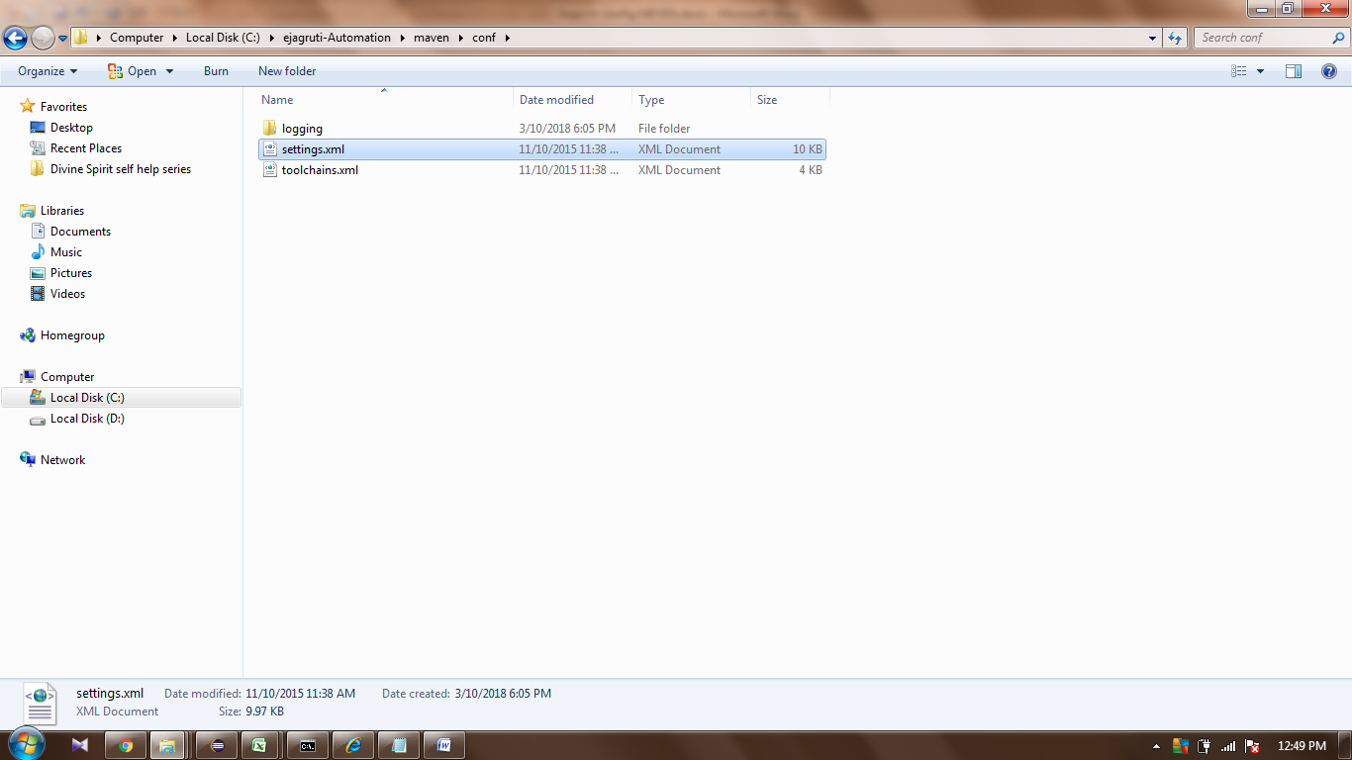

Navigate to Windows>>Preferences>>Maven>>User setting and paste the path under user setting

File will be downloaded to **C:\Users\Ravi\.m2\repository\org\seleniumhq\selenium\selenium-java\3.9.1**

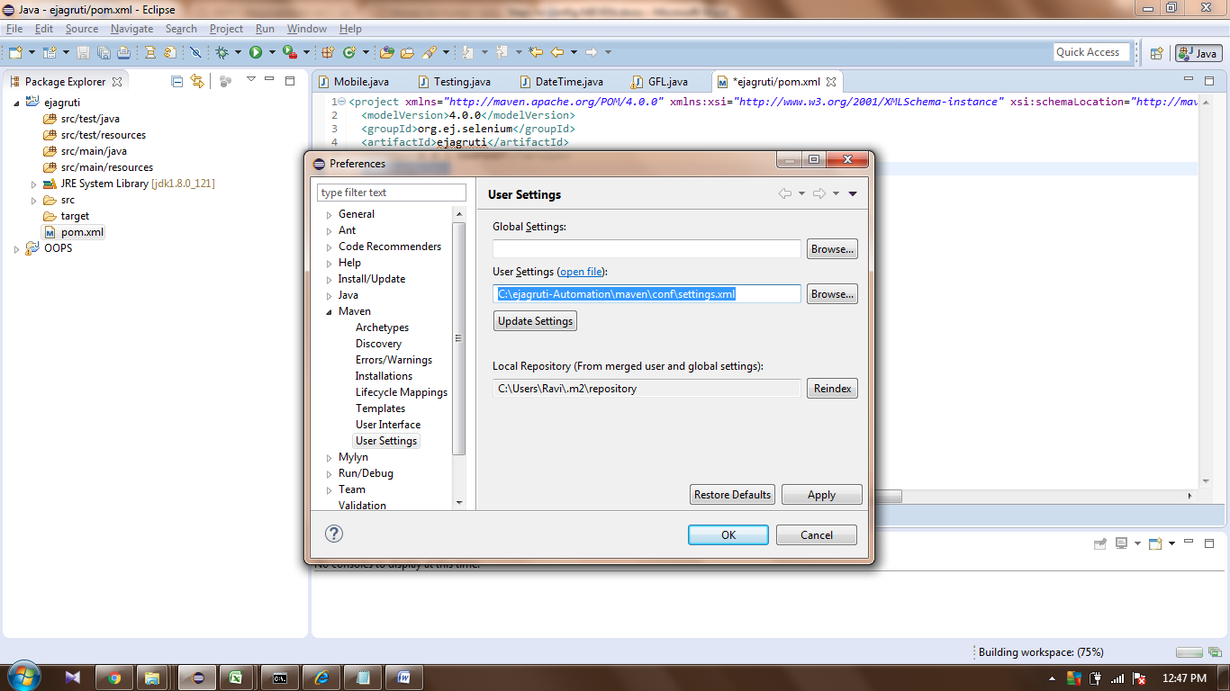

On below path Maven will store the required files (Mention in above image)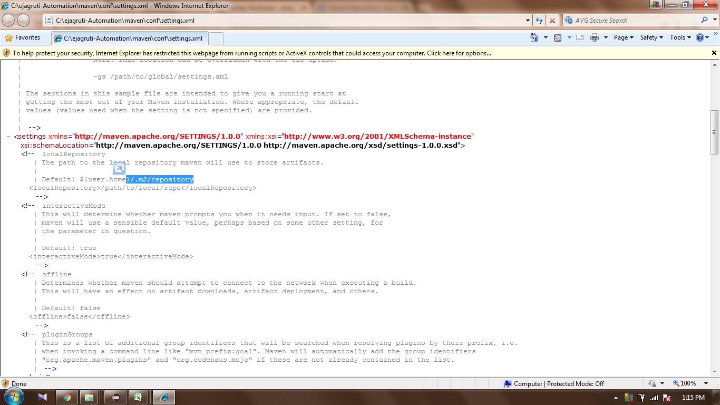

4. Open cmd and navigate to project path (where we have saved our project in workspace)

enter **mvn eclipse:eclipe** and press enter key (then project will download the required files) so it will download the external liberies

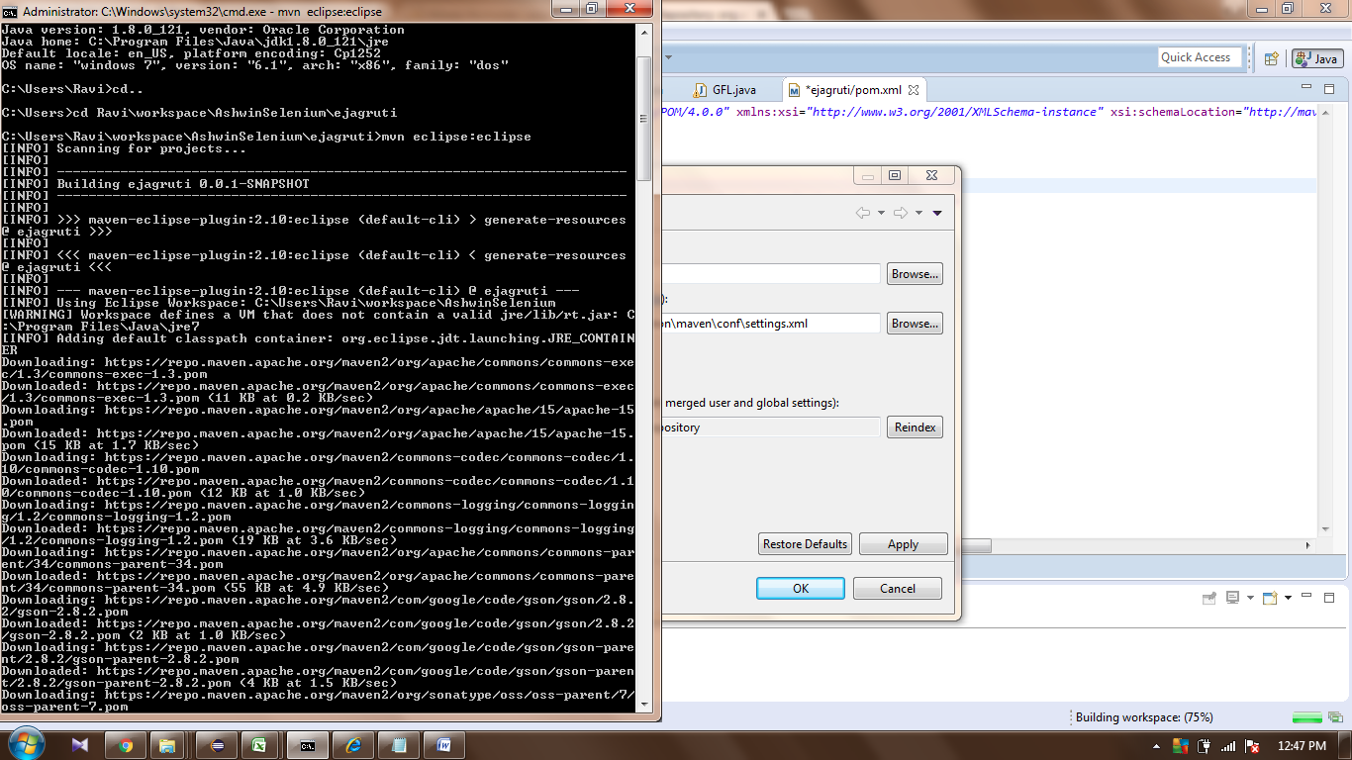 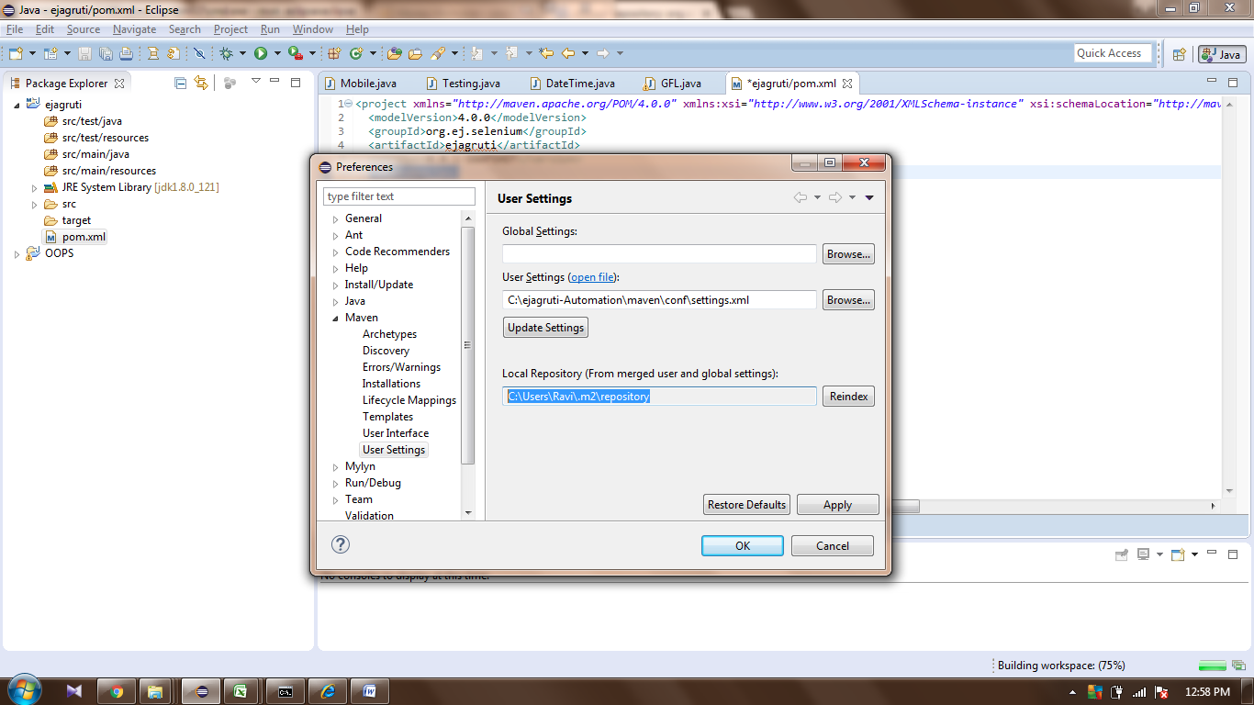

//End Result from CMD

Microsoft Windows [Version 6.1.7600]

Copyright (c) 2009 Microsoft Corporation. All rights reserved.

C:\Users\Ravi>mvn -version

Apache Maven 3.3.9 (bb52d8502b132ec0a5a3f4c09453c07478323dc5; 2015-11-10T22:11:4

7+05:30)

Maven home: C:\ejagruti-Automation\maven

Java version: 1.8.0_121, vendor: Oracle Corporation

Java home: C:\Program Files\Java\jdk1.8.0_121\jre

Default locale: en_US, platform encoding: Cp1252

OS name: "windows 7", version: "6.1", arch: "x86", family: "dos"

C:\Users\Ravi>cd..

C:\Users>cd Ravi\workspace\AshwinSelenium\ejagruti

C:\Users\Ravi\workspace\AshwinSelenium\ejagruti>mvn eclipse:eclipse

[INFO] Scanning for projects...

[INFO]

[INFO] ------------------------------------------------------------------------

[INFO] Building ejagruti 0.0.1-SNAPSHOT

[INFO] ------------------------------------------------------------------------

[INFO]

[INFO] >>> maven-eclipse-plugin:2.10:eclipse (default-cli) > generate-resources

@ ejagruti >>>

[INFO]

[INFO] <<< maven-eclipse-plugin:2.10:eclipse (default-cli) < generate-resources

@ ejagruti <<<

[INFO]

[INFO] --- maven-eclipse-plugin:2.10:eclipse (default-cli) @ ejagruti ---

[INFO] Using Eclipse Workspace: C:\Users\Ravi\workspace\AshwinSelenium

[WARNING] Workspace defines a VM that does not contain a valid jre/lib/rt.jar: C

:\Program Files\Java\jre7

[INFO] Adding default classpath container: org.eclipse.jdt.launching.JRE_CONTAIN

ER

Downloading: https://repo.maven.apache.org/maven2/org/apache/commons/commons-exe

c/1.3/commons-exec-1.3.pom

Downloaded: https://repo.maven.apache.org/maven2/org/apache/commons/commons-exec

/1.3/commons-exec-1.3.pom (11 KB at 0.2 KB/sec)

Downloading: https://repo.maven.apache.org/maven2/org/apache/apache/15/apache-15

.pom

Downloaded: https://repo.maven.apache.org/maven2/org/apache/apache/15/apache-15.

pom (15 KB at 1.7 KB/sec)

Downloading: https://repo.maven.apache.org/maven2/commons-codec/commons-codec/1.

10/commons-codec-1.10.pom

Downloaded: https://repo.maven.apache.org/maven2/commons-codec/commons-codec/1.1

0/commons-codec-1.10.pom (12 KB at 1.0 KB/sec)

Downloading: https://repo.maven.apache.org/maven2/commons-logging/commons-loggin

g/1.2/commons-logging-1.2.pom

Downloaded: https://repo.maven.apache.org/maven2/commons-logging/commons-logging

/1.2/commons-logging-1.2.pom (19 KB at 3.6 KB/sec)

Downloading: https://repo.maven.apache.org/maven2/org/apache/commons/commons-par

ent/34/commons-parent-34.pom

Downloaded: https://repo.maven.apache.org/maven2/org/apache/commons/commons-pare

nt/34/commons-parent-34.pom (55 KB at 4.9 KB/sec)

Downloading: https://repo.maven.apache.org/maven2/com/google/code/gson/gson/2.8.

2/gson-2.8.2.pom

Downloaded: https://repo.maven.apache.org/maven2/com/google/code/gson/gson/2.8.2

/gson-2.8.2.pom (2 KB at 1.0 KB/sec)

Downloading: https://repo.maven.apache.org/maven2/com/google/code/gson/gson-pare

nt/2.8.2/gson-parent-2.8.2.pom

Downloaded: https://repo.maven.apache.org/maven2/com/google/code/gson/gson-paren

t/2.8.2/gson-parent-2.8.2.pom (4 KB at 1.5 KB/sec)

Downloading: https://repo.maven.apache.org/maven2/org/sonatype/oss/oss-parent/7/

oss-parent-7.pom

Downloaded: https://repo.maven.apache.org/maven2/org/sonatype/oss/oss-parent/7/o

ss-parent-7.pom (5 KB at 1.9 KB/sec)

Downloading: https://repo.maven.apache.org/maven2/com/google/guava/guava/23.6-jr

e/guava-23.6-jre.pom

Downloaded: https://repo.maven.apache.org/maven2/com/google/guava/guava/23.6-jre

/guava-23.6-jre.pom (8 KB at 2.4 KB/sec)

Downloading: https://repo.maven.apache.org/maven2/com/google/guava/guava-parent/

23.6-jre/guava-parent-23.6-jre.pom

Downloaded: https://repo.maven.apache.org/maven2/com/google/guava/guava-parent/2

3.6-jre/guava-parent-23.6-jre.pom (10 KB at 5.4 KB/sec)

Downloading: https://repo.maven.apache.org/maven2/org/sonatype/oss/oss-parent/9/

oss-parent-9.pom

Downloaded: https://repo.maven.apache.org/maven2/org/sonatype/oss/oss-parent/9/o

ss-parent-9.pom (7 KB at 0.7 KB/sec)

Downloading: https://repo.maven.apache.org/maven2/com/google/code/findbugs/jsr30

5/1.3.9/jsr305-1.3.9.pom

Downloaded: https://repo.maven.apache.org/maven2/com/google/code/findbugs/jsr305

/1.3.9/jsr305-1.3.9.pom (965 B at 0.4 KB/sec)

Downloading: https://repo.maven.apache.org/maven2/org/checkerframework/checker-c

ompat-qual/2.0.0/checker-compat-qual-2.0.0.pom

Downloaded: https://repo.maven.apache.org/maven2/org/checkerframework/checker-co

mpat-qual/2.0.0/checker-compat-qual-2.0.0.pom (5 KB at 1.3 KB/sec)

Downloading: https://repo.maven.apache.org/maven2/com/google/errorprone/error_pr

one_annotations/2.1.3/error_prone_annotations-2.1.3.pom

Downloaded: https://repo.maven.apache.org/maven2/com/google/errorprone/error_pro

ne_annotations/2.1.3/error_prone_annotations-2.1.3.pom (2 KB at 0.8 KB/sec)

Downloading: https://repo.maven.apache.org/maven2/com/google/errorprone/error_pr

one_parent/2.1.3/error_prone_parent-2.1.3.pom

Downloaded: https://repo.maven.apache.org/maven2/com/google/errorprone/error_pro

ne_parent/2.1.3/error_prone_parent-2.1.3.pom (5 KB at 1.8 KB/sec)

Downloading: https://repo.maven.apache.org/maven2/com/google/j2objc/j2objc-annot

ations/1.1/j2objc-annotations-1.1.pom

Downloaded: https://repo.maven.apache.org/maven2/com/google/j2objc/j2objc-annota

tions/1.1/j2objc-annotations-1.1.pom (3 KB at 1.5 KB/sec)

Downloading: https://repo.maven.apache.org/maven2/org/codehaus/mojo/animal-sniff

er-annotations/1.14/animal-sniffer-annotations-1.14.pom

Downloaded: https://repo.maven.apache.org/maven2/org/codehaus/mojo/animal-sniffe

r-annotations/1.14/animal-sniffer-annotations-1.14.pom (3 KB at 1.3 KB/sec)

Downloading: https://repo.maven.apache.org/maven2/org/codehaus/mojo/animal-sniff

er-parent/1.14/animal-sniffer-parent-1.14.pom

Mar 11, 2018 12:33:20 PM org.apache.maven.wagon.providers.http.httpclient.impl.e

xecchain.RetryExec execute

INFO: I/O exception (java.net.SocketException) caught when processing request to

{s}->https://repo.maven.apache.org:443: Connection reset

Mar 11, 2018 12:33:20 PM org.apache.maven.wagon.providers.http.httpclient.impl.e

xecchain.RetryExec execute

INFO: Retrying request to {s}->https://repo.maven.apache.org:443

Downloaded: https://repo.maven.apache.org/maven2/org/codehaus/mojo/animal-sniffe

r-parent/1.14/animal-sniffer-parent-1.14.pom (5 KB at 0.1 KB/sec)

Downloading: https://repo.maven.apache.org/maven2/org/codehaus/mojo/mojo-parent/

34/mojo-parent-34.pom

Downloaded: https://repo.maven.apache.org/maven2/org/codehaus/mojo/mojo-parent/3

4/mojo-parent-34.pom (24 KB at 13.5 KB/sec)

Downloading: https://repo.maven.apache.org/maven2/org/codehaus/codehaus-parent/4

/codehaus-parent-4.pom

Downloaded: https://repo.maven.apache.org/maven2/org/codehaus/codehaus-parent/4/

codehaus-parent-4.pom (5 KB at 6.4 KB/sec)

Downloading: https://repo.maven.apache.org/maven2/org/apache/httpcomponents/http

client/4.5.3/httpclient-4.5.3.pom

Downloaded: https://repo.maven.apache.org/maven2/org/apache/httpcomponents/httpc

lient/4.5.3/httpclient-4.5.3.pom (7 KB at 7.8 KB/sec)

Downloading: https://repo.maven.apache.org/maven2/org/apache/httpcomponents/http

components-client/4.5.3/httpcomponents-client-4.5.3.pom

Downloaded: https://repo.maven.apache.org/maven2/org/apache/httpcomponents/httpc

omponents-client/4.5.3/httpcomponents-client-4.5.3.pom (16 KB at 5.9 KB/sec)

Downloading: https://repo.maven.apache.org/maven2/org/apache/httpcomponents/proj

ect/7/project-7.pom

Downloaded: https://repo.maven.apache.org/maven2/org/apache/httpcomponents/proje

ct/7/project-7.pom (27 KB at 12.1 KB/sec)

Downloading: https://repo.maven.apache.org/maven2/org/apache/httpcomponents/http

core/4.4.6/httpcore-4.4.6.pom

Downloaded: https://repo.maven.apache.org/maven2/org/apache/httpcomponents/httpc

ore/4.4.6/httpcore-4.4.6.pom (5 KB at 5.5 KB/sec)

Downloading: https://repo.maven.apache.org/maven2/org/apache/httpcomponents/http

components-core/4.4.6/httpcomponents-core-4.4.6.pom

Downloaded: https://repo.maven.apache.org/maven2/org/apache/httpcomponents/httpc

omponents-core/4.4.6/httpcomponents-core-4.4.6.pom (14 KB at 9.8 KB/sec)

Downloading: https://repo.maven.apache.org/maven2/commons-codec/commons-codec/1.

9/commons-codec-1.9.pom

Downloaded: https://repo.maven.apache.org/maven2/commons-codec/commons-codec/1.9

/commons-codec-1.9.pom (12 KB at 5.9 KB/sec)

Downloading: https://repo.maven.apache.org/maven2/org/apache/commons/commons-par

ent/32/commons-parent-32.pom

Downloaded: https://repo.maven.apache.org/maven2/org/apache/commons/commons-pare

nt/32/commons-parent-32.pom (52 KB at 12.5 KB/sec)

Downloading: https://repo.maven.apache.org/maven2/com/squareup/okhttp3/okhttp/3.

9.1/okhttp-3.9.1.pom

Downloaded: https://repo.maven.apache.org/maven2/com/squareup/okhttp3/okhttp/3.9

.1/okhttp-3.9.1.pom (2 KB at 2.8 KB/sec)

Downloading: https://repo.maven.apache.org/maven2/com/squareup/okhttp3/parent/3.

9.1/parent-3.9.1.pom

Downloaded: https://repo.maven.apache.org/maven2/com/squareup/okhttp3/parent/3.9

.1/parent-3.9.1.pom (18 KB at 6.5 KB/sec)

Downloading: https://repo.maven.apache.org/maven2/com/squareup/okio/okio/1.13.0/

okio-1.13.0.pom

Downloaded: https://repo.maven.apache.org/maven2/com/squareup/okio/okio/1.13.0/o

kio-1.13.0.pom (2 KB at 2.5 KB/sec)

Downloading: https://repo.maven.apache.org/maven2/com/squareup/okio/okio-parent/

1.13.0/okio-parent-1.13.0.pom

Downloaded: https://repo.maven.apache.org/maven2/com/squareup/okio/okio-parent/1

.13.0/okio-parent-1.13.0.pom (5 KB at 4.8 KB/sec)

Downloading: https://repo.maven.apache.org/maven2/org/seleniumhq/selenium/seleni

um-edge-driver/3.9.1/selenium-edge-driver-3.9.1.pom

Downloaded: https://repo.maven.apache.org/maven2/org/seleniumhq/selenium/seleniu

m-edge-driver/3.9.1/selenium-edge-driver-3.9.1.pom (5 KB at 3.7 KB/sec)

Downloading: https://repo.maven.apache.org/maven2/org/seleniumhq/selenium/seleni

um-firefox-driver/3.9.1/selenium-firefox-driver-3.9.1.pom

Downloaded: https://repo.maven.apache.org/maven2/org/seleniumhq/selenium/seleniu

m-firefox-driver/3.9.1/selenium-firefox-driver-3.9.1.pom (5 KB at 5.0 KB/sec)

Downloading: https://repo.maven.apache.org/maven2/org/seleniumhq/selenium/seleni

um-ie-driver/3.9.1/selenium-ie-driver-3.9.1.pom

Downloaded: https://repo.maven.apache.org/maven2/org/seleniumhq/selenium/seleniu

m-ie-driver/3.9.1/selenium-ie-driver-3.9.1.pom (5 KB at 7.0 KB/sec)

Downloading: https://repo.maven.apache.org/maven2/org/seleniumhq/selenium/seleni

um-opera-driver/3.9.1/selenium-opera-driver-3.9.1.pom

Downloaded: https://repo.maven.apache.org/maven2/org/seleniumhq/selenium/seleniu

m-opera-driver/3.9.1/selenium-opera-driver-3.9.1.pom (5 KB at 6.9 KB/sec)

Downloading: https://repo.maven.apache.org/maven2/org/seleniumhq/selenium/seleni

um-safari-driver/3.9.1/selenium-safari-driver-3.9.1.pom

Downloaded: https://repo.maven.apache.org/maven2/org/seleniumhq/selenium/seleniu

m-safari-driver/3.9.1/selenium-safari-driver-3.9.1.pom (5 KB at 5.1 KB/sec)

Downloading: https://repo.maven.apache.org/maven2/org/seleniumhq/selenium/seleni

um-support/3.9.1/selenium-support-3.9.1.pom

Downloaded: https://repo.maven.apache.org/maven2/org/seleniumhq/selenium/seleniu

m-support/3.9.1/selenium-support-3.9.1.pom (5 KB at 7.0 KB/sec)

Downloading: https://repo.maven.apache.org/maven2/org/seleniumhq/selenium/seleni

um-java/3.9.1/selenium-java-3.9.1.jar

Downloaded: https://repo.maven.apache.org/maven2/org/seleniumhq/selenium/seleniu

m-java/3.9.1/selenium-java-3.9.1.jar (293 B at 0.4 KB/sec)

Downloading: https://repo.maven.apache.org/maven2/org/seleniumhq/selenium/seleni

um-api/3.9.1/selenium-api-3.9.1.jar

Downloaded: https://repo.maven.apache.org/maven2/org/seleniumhq/selenium/seleniu

m-api/3.9.1/selenium-api-3.9.1.jar (112 KB at 14.3 KB/sec)

Downloading: https://repo.maven.apache.org/maven2/org/seleniumhq/selenium/seleni

um-chrome-driver/3.9.1/selenium-chrome-driver-3.9.1.jar

Downloaded: https://repo.maven.apache.org/maven2/org/seleniumhq/selenium/seleniu

m-chrome-driver/3.9.1/selenium-chrome-driver-3.9.1.jar (11 KB at 9.8 KB/sec)

Downloading: https://repo.maven.apache.org/maven2/org/seleniumhq/selenium/seleni

um-remote-driver/3.9.1/selenium-remote-driver-3.9.1.jar

Downloaded: https://repo.maven.apache.org/maven2/org/seleniumhq/selenium/seleniu

m-remote-driver/3.9.1/selenium-remote-driver-3.9.1.jar (349 KB at 30.9 KB/sec)

Downloading: https://repo.maven.apache.org/maven2/net/bytebuddy/byte-buddy/1.7.9

/byte-buddy-1.7.9.jar

Downloaded: https://repo.maven.apache.org/maven2/net/bytebuddy/byte-buddy/1.7.9/

byte-buddy-1.7.9.jar (2856 KB at 19.2 KB/sec)

Downloading: https://repo.maven.apache.org/maven2/org/apache/commons/commons-exe

c/1.3/commons-exec-1.3.jar

Downloaded: https://repo.maven.apache.org/maven2/org/apache/commons/commons-exec

/1.3/commons-exec-1.3.jar (54 KB at 28.7 KB/sec)

Downloading: https://repo.maven.apache.org/maven2/commons-codec/commons-codec/1.

10/commons-codec-1.10.jar

Downloaded: https://repo.maven.apache.org/maven2/commons-codec/commons-codec/1.1

0/commons-codec-1.10.jar (278 KB at 24.8 KB/sec)

Downloading: https://repo.maven.apache.org/maven2/commons-logging/commons-loggin

g/1.2/commons-logging-1.2.jar

Downloaded: https://repo.maven.apache.org/maven2/commons-logging/commons-logging

/1.2/commons-logging-1.2.jar (61 KB at 4.9 KB/sec)

Downloading: https://repo.maven.apache.org/maven2/com/google/code/gson/gson/2.8.

2/gson-2.8.2.jar

[WARNING] An error occurred during dependency resolution of the following artifa

ct:

com.google.code.gson:gson:2.8.2

Caused by: Could not transfer artifact com.google.code.gson:gson:jar:2.8.2 from/

to central (https://repo.maven.apache.org/maven2): GET request of: com/google/co

de/gson/gson/2.8.2/gson-2.8.2.jar from central failed

com.google.code.gson:gson:jar:2.8.2

from the specified remote repositories:

central (https://repo.maven.apache.org/maven2, releases=true, snapshots=false)

Path to dependency:

1) org.ej.selenium:ejagruti:jar:0.0.1-SNAPSHOT

2) org.seleniumhq.selenium:selenium-java:jar:3.9.1

3) com.google.code.gson:gson:jar:2.8.2

[INFO] Unable to read jar manifest from C:\Users\Ravi\.m2\repository\com\google\

code\gson\gson\2.8.2\gson-2.8.2.jar

Downloading: https://repo.maven.apache.org/maven2/com/google/guava/guava/23.6-jr

e/guava-23.6-jre.jar

Downloaded: https://repo.maven.apache.org/maven2/com/google/guava/guava/23.6-jre

/guava-23.6-jre.jar (2645 KB at 105.3 KB/sec)

Downloading: https://repo.maven.apache.org/maven2/com/google/code/findbugs/jsr30

5/1.3.9/jsr305-1.3.9.jar

Downloaded: https://repo.maven.apache.org/maven2/com/google/code/findbugs/jsr305

/1.3.9/jsr305-1.3.9.jar (33 KB at 39.3 KB/sec)

Downloading: https://repo.maven.apache.org/maven2/org/checkerframework/checker-c

ompat-qual/2.0.0/checker-compat-qual-2.0.0.jar

Downloaded: https://repo.maven.apache.org/maven2/org/checkerframework/checker-co

mpat-qual/2.0.0/checker-compat-qual-2.0.0.jar (31 KB at 36.7 KB/sec)

Downloading: https://repo.maven.apache.org/maven2/com/google/errorprone/error_pr

one_annotations/2.1.3/error_prone_annotations-2.1.3.jar

Downloaded: https://repo.maven.apache.org/maven2/com/google/errorprone/error_pro

ne_annotations/2.1.3/error_prone_annotations-2.1.3.jar (14 KB at 18.5 KB/sec)

Downloading: https://repo.maven.apache.org/maven2/com/google/j2objc/j2objc-annot

ations/1.1/j2objc-annotations-1.1.jar

Downloaded: https://repo.maven.apache.org/maven2/com/google/j2objc/j2objc-annota

tions/1.1/j2objc-annotations-1.1.jar (9 KB at 14.0 KB/sec)

Downloading: https://repo.maven.apache.org/maven2/org/codehaus/mojo/animal-sniff

er-annotations/1.14/animal-sniffer-annotations-1.14.jar

Downloaded: https://repo.maven.apache.org/maven2/org/codehaus/mojo/animal-sniffe

r-annotations/1.14/animal-sniffer-annotations-1.14.jar (4 KB at 5.9 KB/sec)

Downloading: https://repo.maven.apache.org/maven2/org/apache/httpcomponents/http

client/4.5.3/httpclient-4.5.3.jar

Downloaded: https://repo.maven.apache.org/maven2/org/apache/httpcomponents/httpc

lient/4.5.3/httpclient-4.5.3.jar (731 KB at 108.6 KB/sec)

Downloading: https://repo.maven.apache.org/maven2/org/apache/httpcomponents/http

core/4.4.6/httpcore-4.4.6.jar

Downloaded: https://repo.maven.apache.org/maven2/org/apache/httpcomponents/httpc

ore/4.4.6/httpcore-4.4.6.jar (317 KB at 127.0 KB/sec)

Downloading: https://repo.maven.apache.org/maven2/com/squareup/okhttp3/okhttp/3.

9.1/okhttp-3.9.1.jar

Downloaded: https://repo.maven.apache.org/maven2/com/squareup/okhttp3/okhttp/3.9

.1/okhttp-3.9.1.jar (397 KB at 128.7 KB/sec)

Downloading: https://repo.maven.apache.org/maven2/com/squareup/okio/okio/1.13.0/

okio-1.13.0.jar

Downloaded: https://repo.maven.apache.org/maven2/com/squareup/okio/okio/1.13.0/o

kio-1.13.0.jar (80 KB at 42.2 KB/sec)

[INFO] Not writing settings - defaults suffice

[INFO] File C:\Users\Ravi\workspace\AshwinSelenium\ejagruti\.project already exi

sts.

Additional settings will be preserved, run mvn eclipse:clean if you want

old settings to be removed.

[INFO] Wrote Eclipse project for "ejagruti" to C:\Users\Ravi\workspace\AshwinSel

enium\ejagruti.

[INFO]

[INFO] ------------------------------------------------------------------------

[INFO] BUILD SUCCESS

[INFO] ------------------------------------------------------------------------

[INFO] Total time: 37:19 min

[INFO] Finished at: 2018-03-11T13:07:54+05:30

[INFO] Final Memory: 10M/25M

[INFO] ------------------------------------------------------------------------

C:\Users\Ravi\workspace\AshwinSelenium\ejagruti>